Application Form 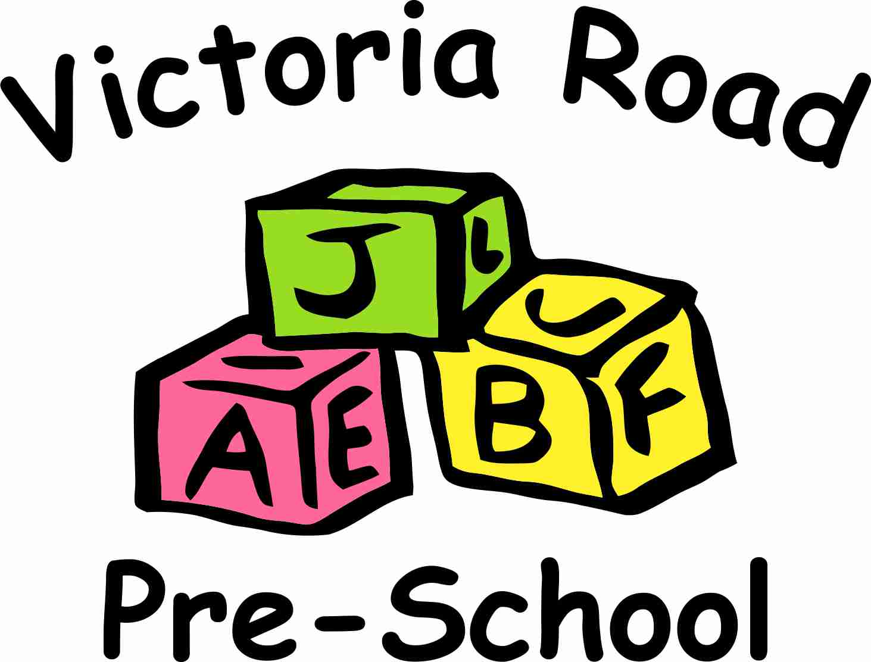
Personal Details
First name(s) of child:
Surname of child: |  |  |  |  | Date of birth:
Male / Female (Please circle/highlight)
Full address:
 |  |  |  |  | Postcode:
Parent/carer name (1):
Relationship to child:
Full address (if different):
 |  |  |  |  | Postcode:
Email Address:
Daytime/Work Tel No.: |  |  | Home No.:
Mobile:
Parent/carer name (2):
Relationship to child:
Full address (if different):
 |  |  |  |  | Postcode:

Daytime/Work Tel. No.: |  | Home No.:
Mobile:

Which Council District does your address fall under?
Session Request
Preferred start date:
Please tick the sessions you would like your child to attend. Please note that 2 & 3-year-olds can only attend the 3-hour morning sessions. The 5 & 6-hour sessions are for school leavers only (their last year with us before transitioning to primary school.)
9:00am - 12:00pm = 3 hours |  |  | □ Monday | □ Tuesday |  | □ Wednesday |  |  | □ Thursday |  | □ Friday
9:00am - 2:00pm = 5 hours |  |  | □ Monday | □ Tuesday |  | □ Wednesday |  |  | □ Thursday |  | □ Friday
8:50am – 2:50pm = 6 hours  (30-hour children only) |  |  | □ Monday | □ Tuesday |  | □ Wednesday |  |  | □ Thursday |  | □ Friday
Are you eligible for 2-year-old funding? (either Targeted or Working Parent) |  |  |  |  |  |  |  |  | □ YES |  |  | □ NO
This application places your child on our waiting list. We will contact you as soon as a suitable place becomes available. Please note that completion of this form does not guarantee a place for your child.
Once your child is offered a place and you accept it, further personal information and family details are required for our records. Your child’s birth certificate is required at this point.
If you find that you no longer need the place, please inform us as soon as possible. If this is the case, we will not retain the details on this application form (see our Privacy Notice).
Signed parent/carer (1): |  |  |  |  |  |  |  | Date:
Signed parent/carer (2): |  |  |  |  |  |  |  | Date:
Please be advised that this application form and offer of a place is subject to our terms and conditions. By signing this document, you acknowledge that you have read, understood and agree to these terms and conditions. Our prospectus and policies and procedures can be found on our website.
For office use only:
Date of Visit:
Additional Notes:
Admin fee paid (date):

